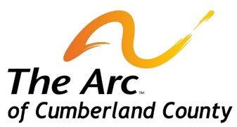
1680 West Sherman Avenue
Vineland, New Jersey 08360

Phone: (856) 691-9138
Fax: (856) 563-0221

www.arccumberland.org

MEMBERSHIP MAIL IN FORM

- Your Arc of Cumberland County membership is tax deductible
- Provides you with membership status with the Arc of New Jersey and the Arc of the United States
- Provides financial assistance to the programs and services of the Arc of Cumberland County

There are only two levels of membership at the Arc of Cumberland County: Please check one.

Regular Membership -$20
Family Membership - $30

Please enclose your check made payable to: The Arc of Cumberland County

Name: _________________________________________________________

Street: ________________________________________________________

City: _____________________________________ State: ____________ Zip: _____________

Telephone: ____________________________________

Email: _________________________________________

Person with a disability Parent Other family member or guardian

Arc of Cumberland professional Supportive Community Member

Please complete this form and send it to our Evanoff Center office address above

THIS PAGE IS A LINK FROM THE OPENING MEMBERSHIP PAGE

